1. Navigate to team project on Azure DevOps in a new browser tab.
2. Import the code from GitHub to azure repos.

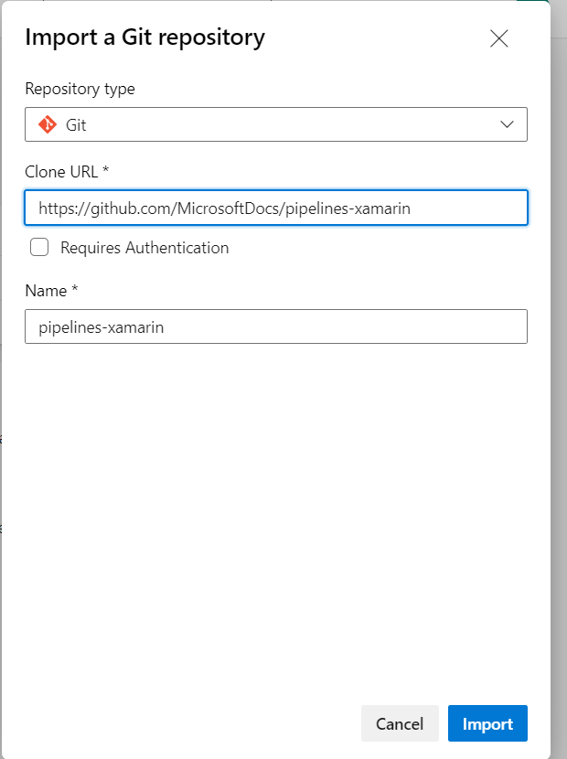

1. Navigate to the Pipelines hub on the left-hand side.
2. Click ‘New Pipeline’. We can use new YAML file or existing YAML file.

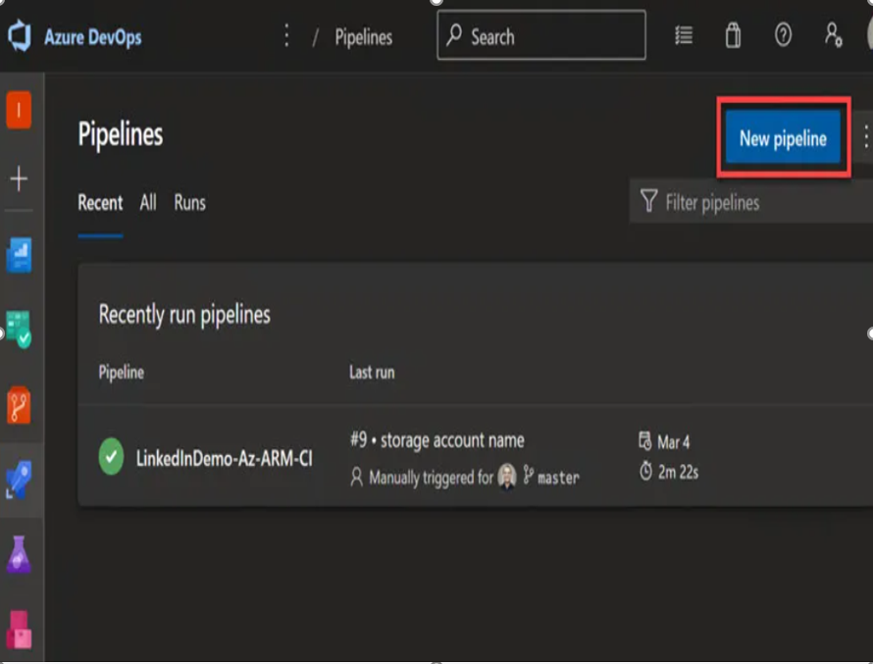

1. Next, select the ‘Azure Repos Git’ as the source hosting platform.

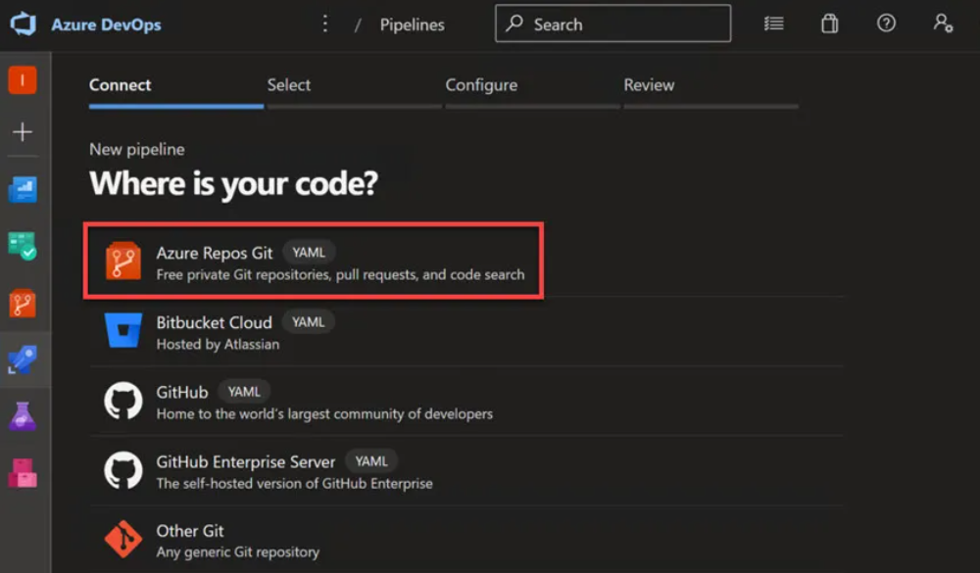

1. Select repository. In this example, the repo is called ‘pipelines-xamrin’.

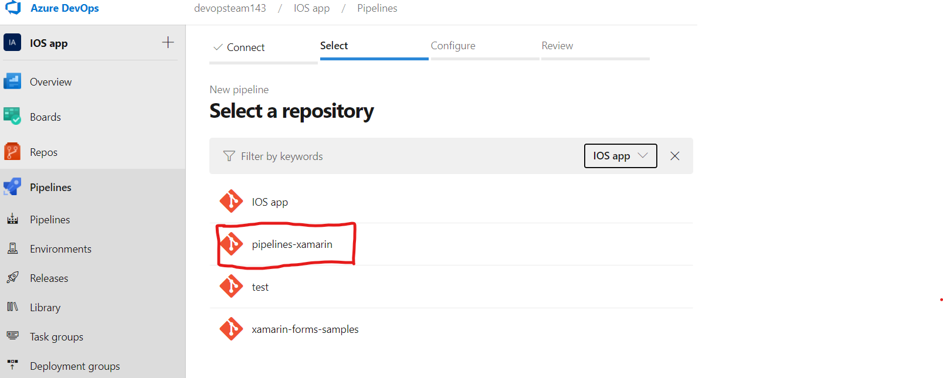

1. Next, select the ‘Existing Azure Pipelines file’ template.

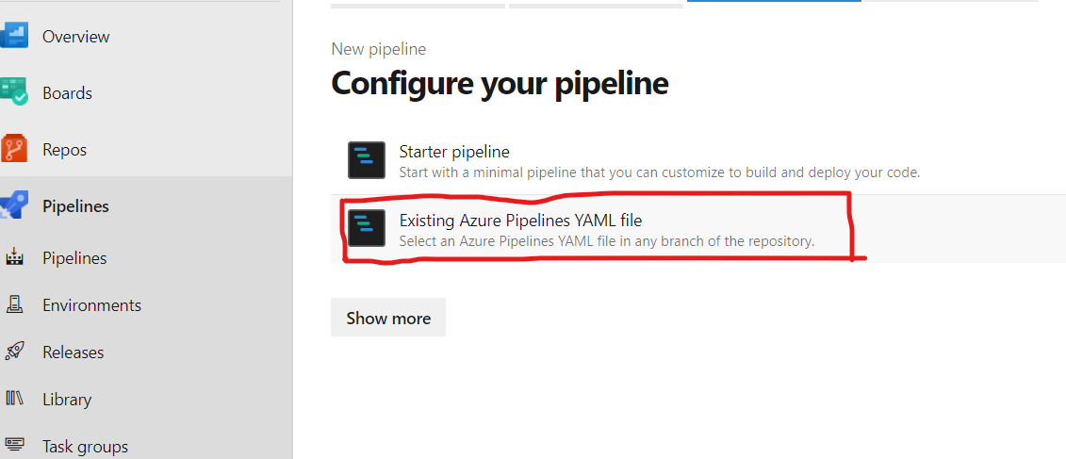

1. The Existing Azure Pipelines file’ will open existing YAML definition.

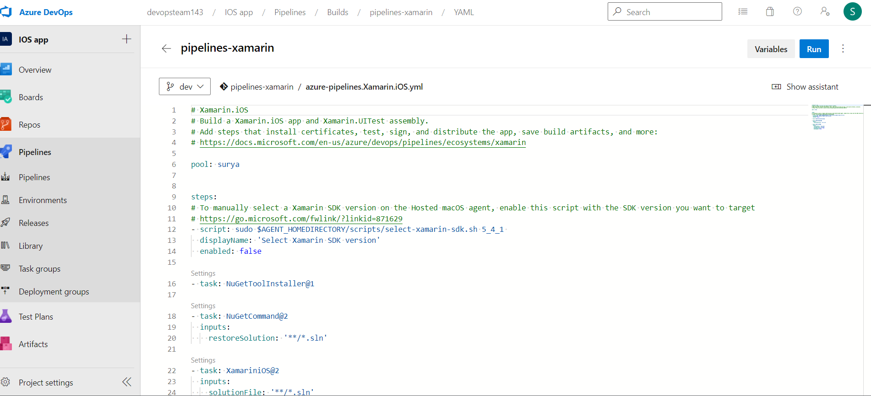

1. Next, we need to change the YAML definition as per our project requirement. Please refer the below example.

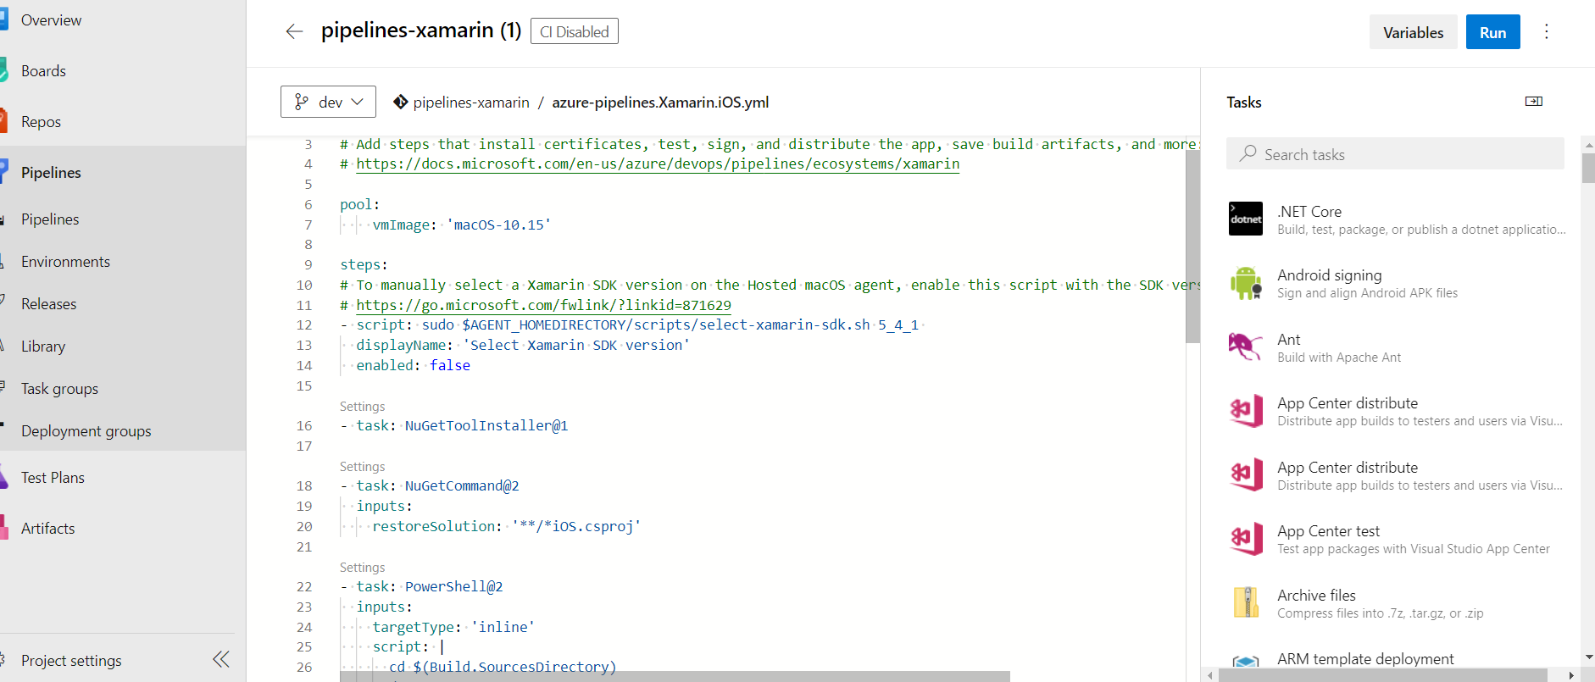

1. Finally, click Save and run the pipeline.

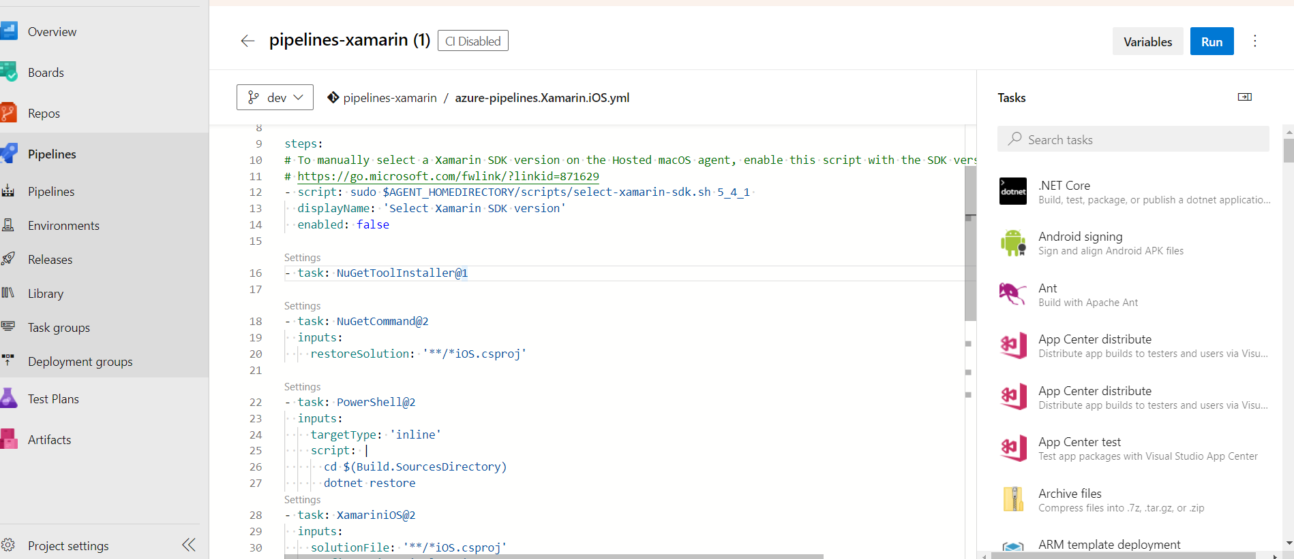

1. While running the script we got error at xamarinios task.

Error details are: ##[error]Xamarin.iOS task failed with error Error: The process '/Library/Frameworks/Mono.framework/Versions/Current/Commands/msbuild' failed with exit code 1

Rectifier this error we added below powershell task

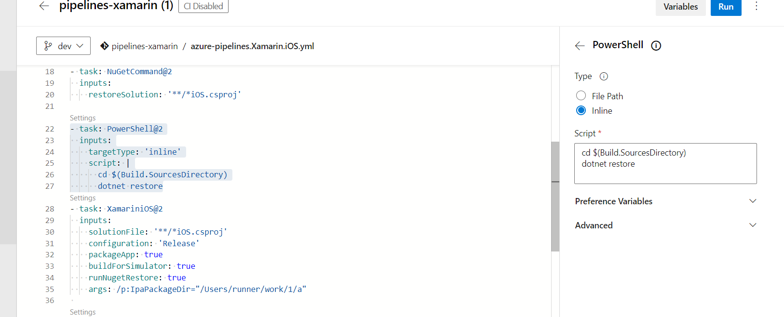

1. Basic Task used in YAML file composition:

* NuGet Tool Installer task : NuGetToolInstaller@1

Use this task to find, download, and cache a specified version of NuGet and add it to

the PATH.

task: NuGetToolInstaller@1

* NuGet task**:** NuGetCommand@2

Use this task to install and update NuGet package dependencies, or package and publish NuGet packages.

# Xamarin.iOS task : XamariniOS@2

# Use this task in a pipeline to build an iOS app with Xamarin on macOS.

# Solution : Relative path from the repository root of the Xamarin.iOS solution or csproj project to build.

# Configuration : Standard configurations are Ad-Hoc, AppStore, Debug, Release.

# Build for iOS Simulator : Optionally build for the iOS Simulator instead of physical iOS devices.

# Create app package : Indicates whether an IPA should be generated as a part of the build.

1. Then integrate the Veracode to build.

Go to organization settings then select extension go to marketplace search veracode then install.

1. Then add the Veracode task.

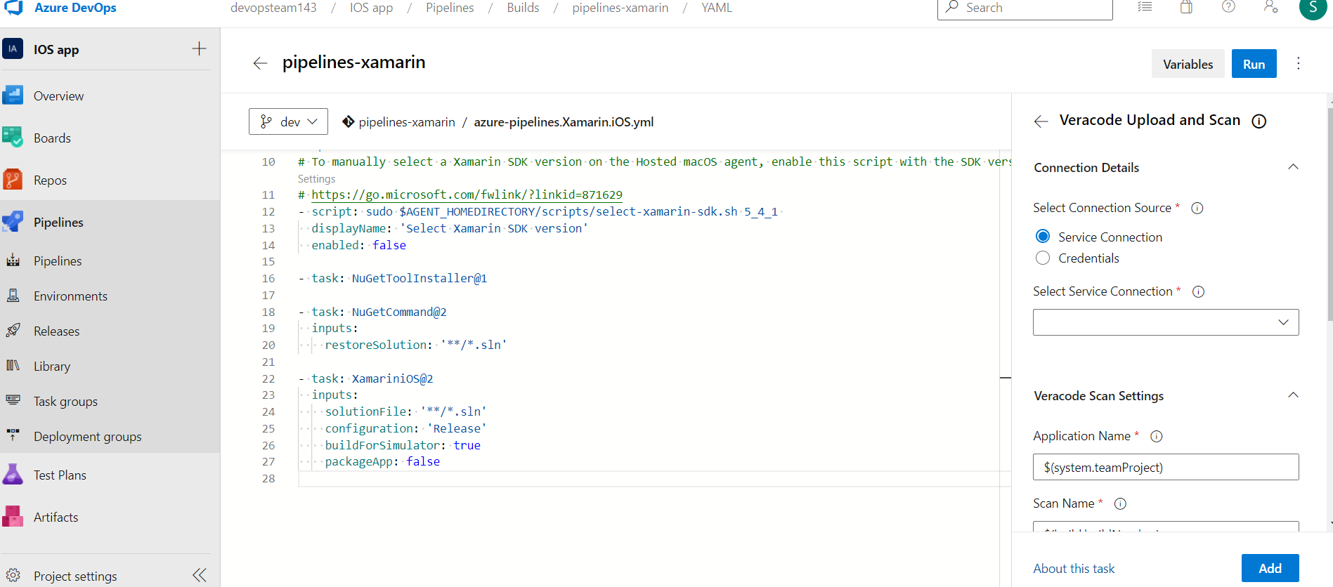

1. Finally, we receive an email if the build failed or succeeded similar to the below.

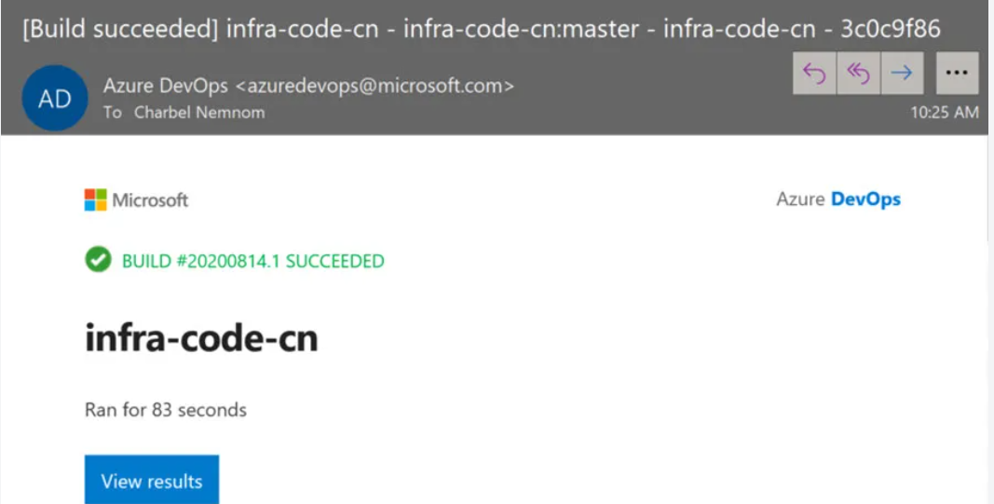

1. You can find the above sample source code on GitHub.

Github URL: [GitHub - MicrosoftDocs/pipelines-xamarin: Sample Xamarin application referred to by Azure Pipelines documentation](https://github.com/MicrosoftDocs/pipelines-xamarin)